SCHOOL PHOTOGRAPHS
ORDER FORM 2016/2017
Please fill in this form and enclose it in a sealed envelope along with the indicated amount of money.
Label the envelope: Photography Money and please write your child's name and class on the envelope.
Send the sealed envelope to the school accounts office so that it can be processed quickly and efficiently.
Orders will not be processed after a designed cut-off date. We would like to remind parents that different types of orders can be made as indicated below. Forms may be submitted as soft copies, but payment is expected before prints are ordered.
SCHOOL PHOTOGRAPHY PACKAGES AVAILABLE FOR ORDER
OPTION A: I WILL LIKE TO ORDER COPY/COPIES
8 X 12 PRINT, LAMINATED AND FRAMED.  N6,000 / SIX THOUSAND NAIRA. | OPTION A  PERSONAL PORTRAIT
NAME OF CHILD

CLASS

SIGNED

OPTION B: I WILL LIKE TO ORDER COPY/COPIES
8 X 12 PRINT, LAMINATED AND FRAMED.  N6,500 / SIX THOUSAND, FIVE HUNDRED NAIRA. | OPTION B  PERSONAL PORTRAIT AND CLASS
NAME OF CHILD

CLASS

SIGNED

OPTION BB: I WILL LIKE TO ORDER COPY/COPIES
8 X 12 PRINT, LAMINATED AND FRAMED.  N7,500 / SEVEN THOUSAND FIVE HUNDRED NAIRA. |  | OPTION BB  PERSONAL PORTRAIT AND CLASS (SEPARATE FRAMES)
NAME OF CHILD

CLASS

SIGNED

OPTION C: I WILL LIKE TO ORDER COPY/COPIES
8 X 12 PRINT, LAMINATED AND FRAMED.  N11,000 / ELEVEN THOUSAND NAIRA | OPTION C  PERSONAL PORTRAIT / CLASS  AND SIBLINGS
NAME OF CHILD

CLASS

SIGNED

OPTION D: I WILL LIKE TO ORDER COPY/COPIES
8 X 12 PRINT, LAMINATED AND FRAMED.  N7,000 / SEVEN THOUSAND, FIVE HUNDRED NAIRA. | OPTION D  WHOLE SCHOOL PANORAMIC PHOTO
NAME OF CHILD | 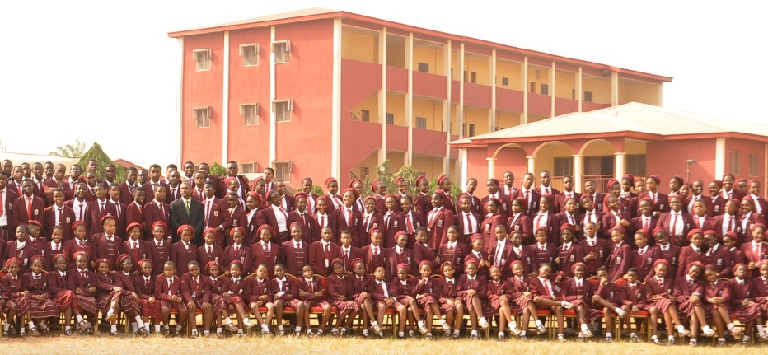
CLASS

SIGNED

OPTION E: I WILL LIKE TO ORDER COPY/COPIES | OPTION F: OPTIONS A, B, BB, C & D
ALL – LAMINATED AND FRAMED
N15,000 / FIVE THOUSAND, FIVE HUNDRED NAIRA.
NAME OF CHILD | NAME OF CHILD
CLASS | CLASS
SIGNED | SIGNED

